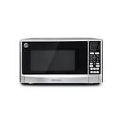

***Tcl auto  
 Microwave oven***

* **Color:**white
* **Available:**in stock
* **Dimension:**1641*595*600
* **Size:**19
* **Old Price:**~~Rs 50,000~~
* **New Price:**Rs 44,000